LO4: Impact of Operator Precedence and NULL Handling

Task 1: Operator Precedence
- Query 1 (no parentheses) + output

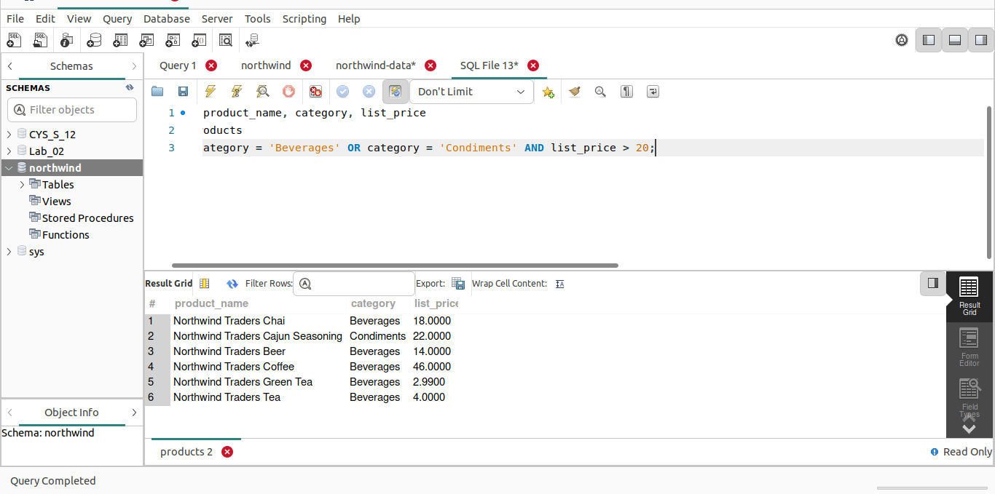
- Query 2 (with parentheses) + output

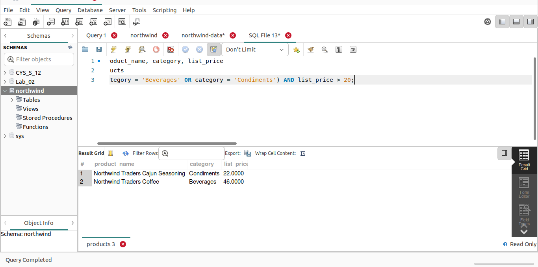
- Conclusion: different results prove precedence

Task 2: NULL Value Handling
- Query showing NULL propagation (Price – Discount)

NULL:
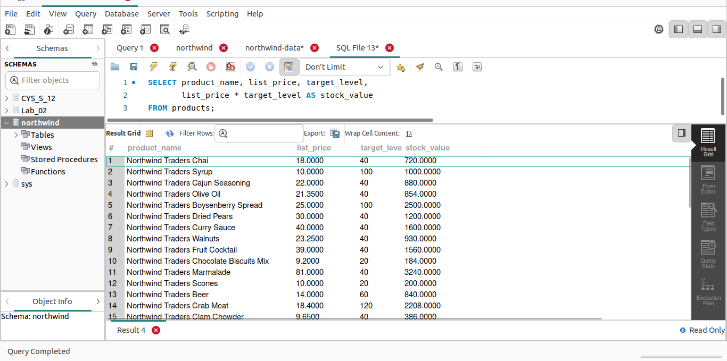

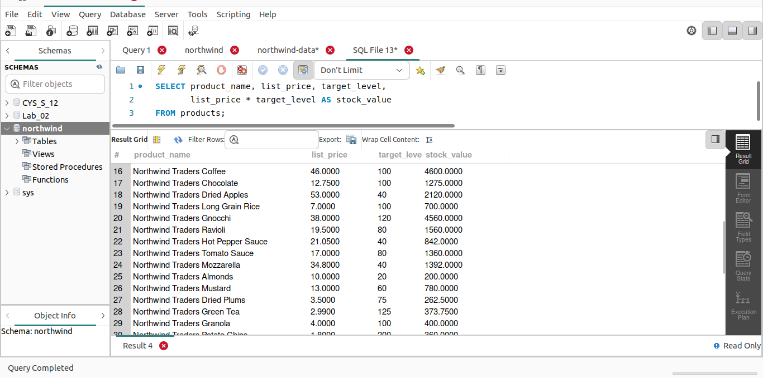

IS NULL:
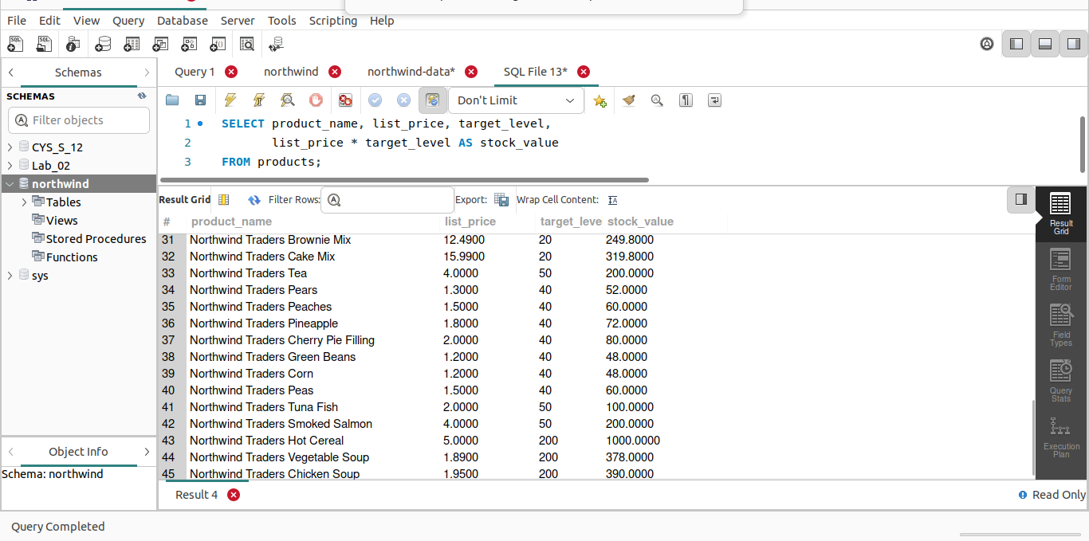
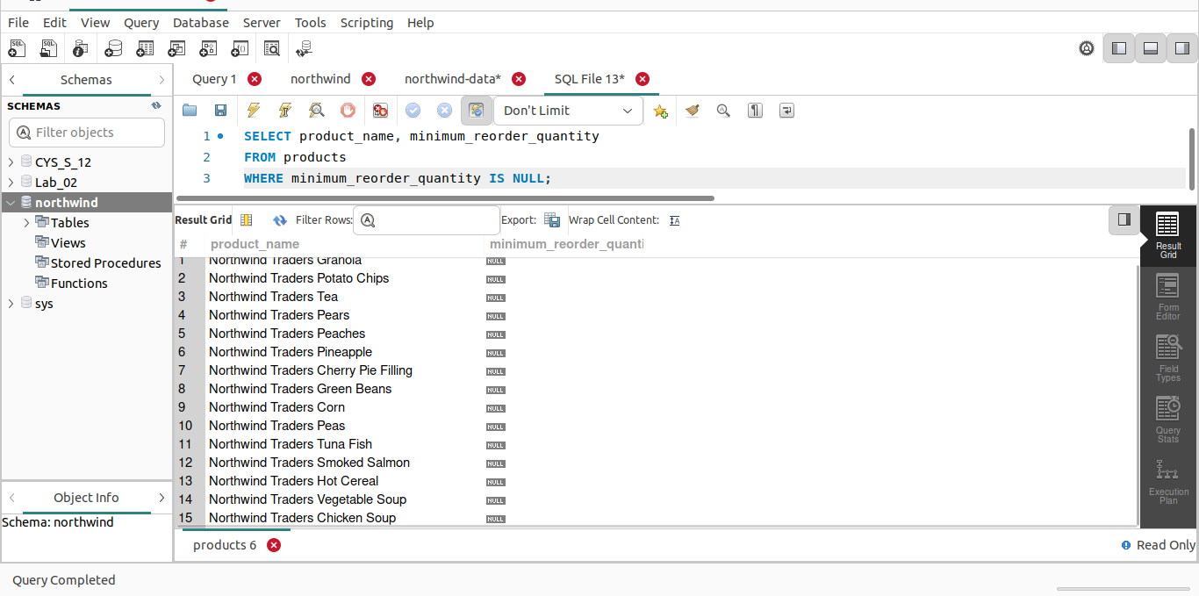
- Query showing IS NULL vs = NULL
- Conclusion: NULL propagates; use IS NULL

